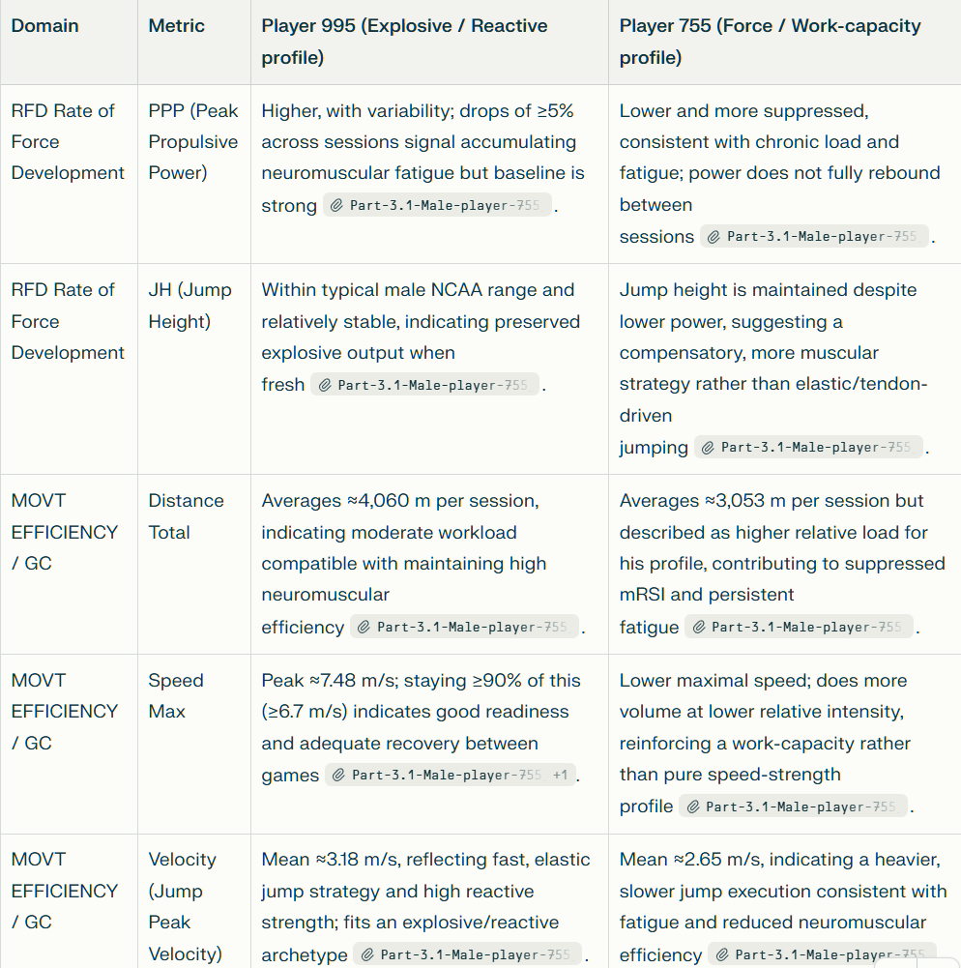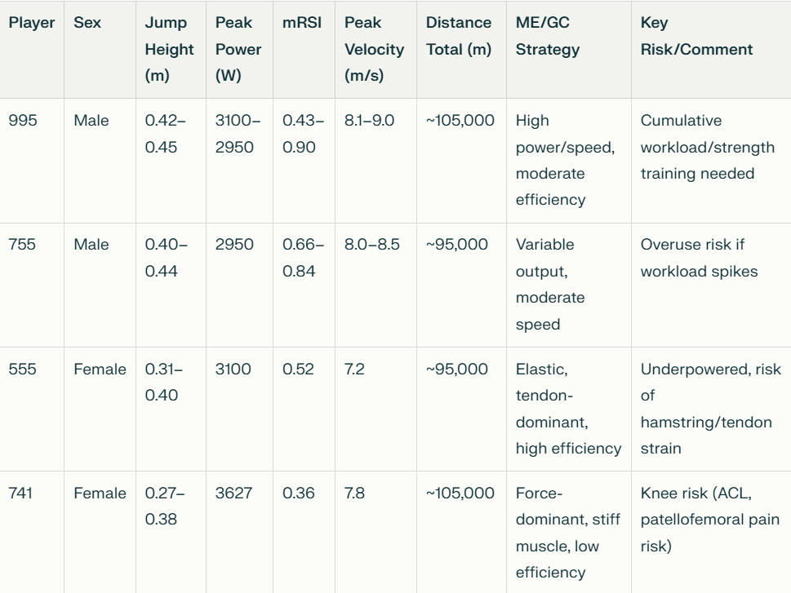

Metric Insights:
- Jump Height, Peak Power, mRSI, Peak Velocity are primary RFD metrics; Distance Total represents ME/GC (volume, efficiency).
- Males (995, 755) typically show higher jump heights, power, and velocities.
- Females diverge: Player 555 relies on tendon elasticity (high mRSI, lower power), while Player 741 exhibits force-dominant strategies (high power, low mRSI, more injury risk).
- Literature supports sex differences: males show greater absolute output; females have more variation in efficiency strategy and injury risk when mRSI/efficiency is low.​
Recommended Actions:
- For males: monitor strength-load balance, avoid overuse by adjusting volume.
- For females: tailor interventions by profile—preserve elastic characteristics in high-efficiency athletes (555), improve neuromuscular control and landing mechanics in force-dominant/at-risk athletes (741).​
Jaison/Perplexity

